Hamza Salahuddin
Lab -02
Task-02
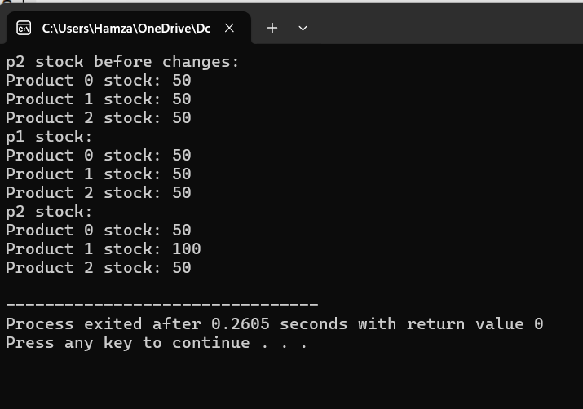
#include <iostream>
using namespace std;

class ProductStockManager {
int* stock;
int size;

public:
ProductStockManager(int n,int initialStock) {
size=n;
stock=new int[size];
for (int i=0;i<size;i++) {
stock[i]=initialStock;
}
}

ProductStockManager(const ProductStockManager& other) {
size=other.size;
stock=new int[size];
for (int i=0; i<size;i++) {
stock[i]=other.stock[i];
}
}

ProductStockManager& operator=(const ProductStockManager& other) {
if (this != &other) {
delete[] stock;
size=other.size;
stock=new int[size];
for (int i=0;i<size;i++) {
stock[i]=other.stock[i];
}
}
return *this;
}

~ProductStockManager() {
delete[] stock;
}

int& operator[](int index) {
if (index<0 || index>=size) {
cout<<"Error:Index out of bounds!"<<endl;
exit(1);
}
return stock[index];
}

void display(){
for (int i = 0; i < size; i++){
cout <<"Product"<<i<<"stock: "<<stock[i]<<endl;
}
}
};

int main() {
ProductStockManager p1(3, 50);
ProductStockManager p2 = p1;
cout << "p2 stock before changes:" << endl;
p2.display();
p2[1] = 100;
cout << "p1 stock:" << endl;
p1.display();
cout << "p2 stock:" << endl;
p2.display();

return 0;
}
Task-03
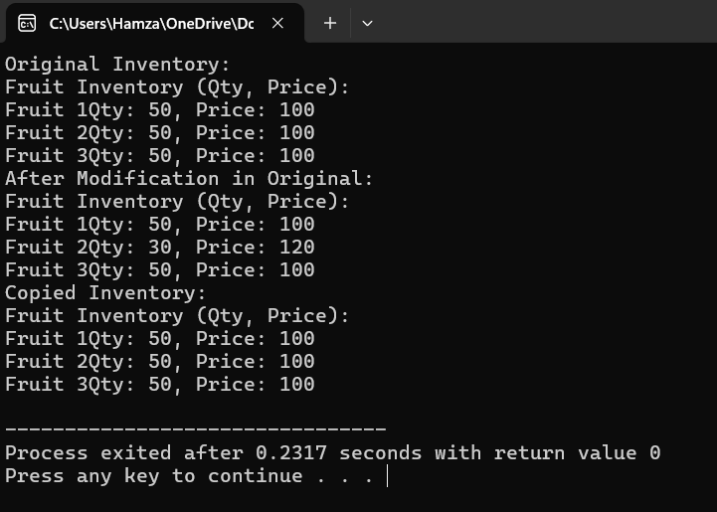
#include<iostream>
using namespace std;

class FruitShopInventory{
int** inventory;
int friutquantity;
public:
FruitShopInventory (int n, int initialquantity, int price)
{
inventory=new int*[friutquantity];
friutquantity=n;
for(int i=0;i<friutquantity;i++){
inventory[i]=new int [2];
inventory[i][0] =initialquantity;
inventory[i][1]=price;
}
}
FruitShopInventory(const FruitShopInventory& other){
friutquantity=other.friutquantity;
inventory=new int*[friutquantity];
for(int i=0;i<friutquantity;i++){
inventory[i] = new int[2];
inventory[i][0] = other.inventory[i][0];
inventory[i][1] = other.inventory[i][1];
}
}
FruitShopInventory & operator=(const FruitShopInventory & other){
if(this !=&other){
for(int i=0;i<friutquantity;i++){
delete[] inventory[i];
}
delete[] inventory;

friutquantity=other.friutquantity;
inventory = new int*[friutquantity];
for (int i=0;i<friutquantity;i++) {
inventory[i]=new int[2];
inventory[i][0]=other.inventory[i][0];
inventory[i][1]=other.inventory[i][1];
}
}
return *this;
}
~FruitShopInventory (){
for(int i=0;i<friutquantity;i++){
delete[] inventory[i];
}
delete[] inventory;
}
void displayInventory() const {
cout <<"\nFruit Inventory (Qty, Price):\n";
for (int i = 0; i <friutquantity; i++) {
cout << "Fruit " <<i+1<< "Qty: "<<inventory[i][0]<<", Price: "<< inventory[i][1] << endl;
}
}
void updateFruit(int index,int quantity,int price){
if(index >= 0 && index<friutquantity){
inventory[index][0]=quantity;
inventory[index][1]=price;
}else{
cout<<"Invalid Index!";
}
}
};

int main() {
FruitShopInventory shop(3, 50, 100);
cout << "Original Inventory:";
shop.displayInventory();

FruitShopInventory copyShop = shop;
shop.updateFruit(1, 30, 120);

cout << "After Modification in Original:";
shop.displayInventory();

cout <<"Copied Inventory:";
copyShop.displayInventory();

return 0;
}
Task-05
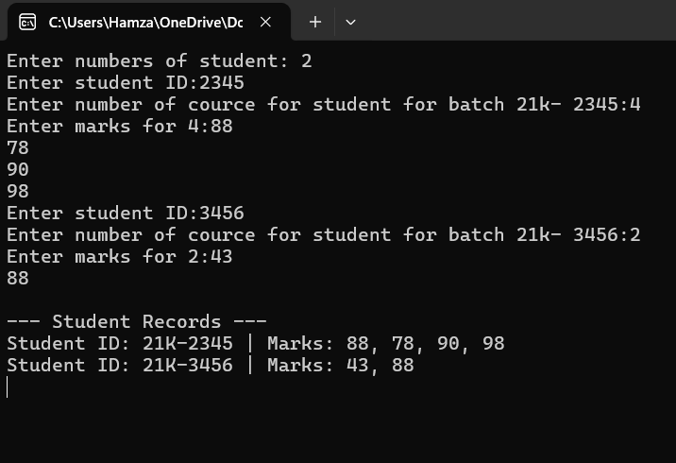
#include<iostream>
using namespace std;

int main(){
int n;
cout<<"Enter numbers of student: ";
cin>>n;
int studentid[n];
int* marks[n];
int courseCount[n];

for(int i=0;i<n;i++){
cout<<"Enter student ID:";
cin>>studentid[i];

cout<<"Enter number of cource for student for batch 21k- "<<studentid[i]<<":";
cin>>courseCount[i];

marks[i]=new int[courseCount[i]];

cout<<"Enter marks for "<<courseCount[i]<<":";
for(int j=0;j<courseCount[i];j++){
cin>>marks[i][j];
}
}
cout << "\n--- Student Records ---\n";
for (int i = 0; i < n; i++) {
cout << "Student ID: 21K-" << studentid[i] << " | Marks: ";
for (int j = 0; j < courseCount[i]; j++) {
cout << marks[i][j];
if (j < courseCount[i] - 1) cout << ", ";
}
cout << endl;
}
for (int i = 0; i < 5; i++) {
delete[] marks[i];
}

return 0;

}

